PITHAPUR RAJAH’S GOVERNMENT DEGREE COLLEGE(A)
Department Of Food Science
Nationa Science Day Celebrations – 2023
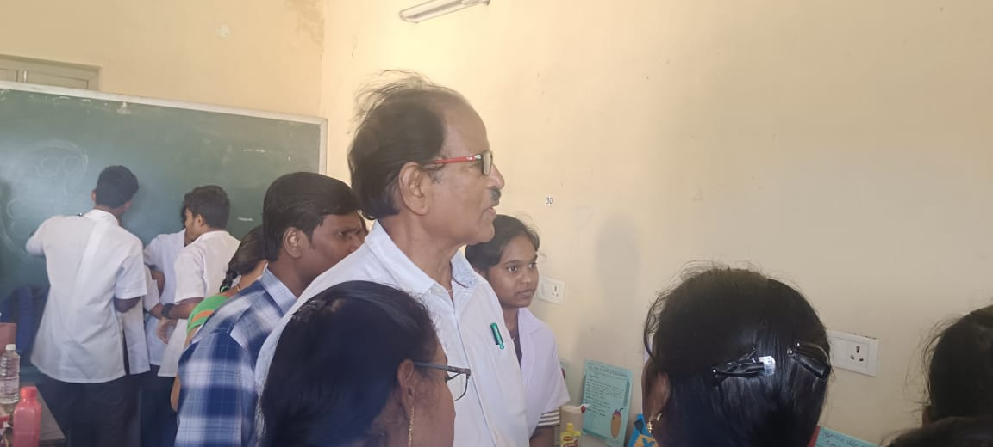
Department of food science celebrated national science day 28thfeb, 2023. Before 3 days of national science dy with encouragement of head of the department students have a developed several working models and projects related to food science subject.

A total 40 students have participated and exhibited their projects. On behalf of science day respected head of the department has renovated the department block.
